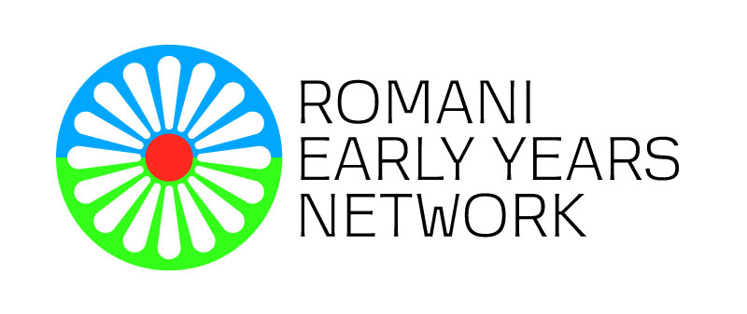
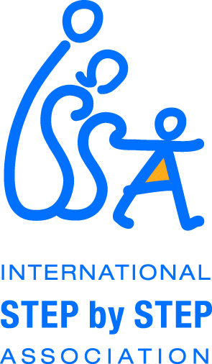

Application Form
REYN Training
Building a Roma Living Library

This application form has to be completed by candidates who are interested in participating in the REYN training on “Building a Roma Living Library”, in Milan, Italy.
We are committed to provide a meaningful and inspiring learning experience for those who will participate in this training. Therefore, we invite the applicants to consider whether they meet the following criteria when writing the application for this REYN activity:
- Be a member of REYN;
- Be a practitioner working in and for Romani communities (educators, teaching assistants, social workers, community mediators, health mediators, home visitors, nurses, doctors, preschool/school inspectors, policy makers etc.);
- Be an activist working on intercultural dialogue and combating prejudices, stigma and discrimination;
- Have sufficient communication skills in English;
- Have trainer’s skills and experience;
- Have a high interest in improving their skills for working in and for Romani communities and young children, and commitment for transferring new knowledge, skills and experiences in own professional context;
- High motivation to learn, share and disseminate valuable and good practices during and after the training.
The information provided below will not be shared with third parties.
Name and Surname
Gender
Age
Country/City:
Educational Status: | High School Associate Degree  University Post Graduate  Doctorate
Spoken Languages (please list the languages in which you can communicate sufficiently to understand and be understood):
Profession and job position (e.g. teacher, trainer, sociologist, community mediator, medical nurse, home visitor, etc.):
Name previous REYN professional development events (e.g. training, meetings, study visits) that you have attended until now. Please indicate if you were a trainer or trainee/host or participant.
Name some previous training in early childhood that you have attended in the past 2 years. Special focus on antibias training. Please specify if you were a trainer or trainee.
Approximate number of Roma children and families that you currently serve from your position:
Organization that you currently are working for:
Cell Phone:
E-mail address:

Are you a member of REYN? YES/NO
Why do you want to participate in this training? What is the relevance of this training to the work you are doing? Please be as specific as possible in explaining your motivation to participate in this training and in providing information on how you can relate the content of the training with your current work with Romani children, families and communities).
What do you see as a benefit of this training for your professional development and for the children, families and communities, you are working with? Please name specific benefits that you envisage by participating in the training.
What would you like to share during the training from your experience given its thematic focus? Please name at least three things that you would like to share from your experience related to the theme of the training.
How are you going to organize Living Library events in your country, community? Please indicate concrete ways that you have in mind for sharing with your peers and colleagues after the training.
If you have participated in any of previous REYN professional development activities please specify benefits and how you have shared knowledge/skills/experiences that you gained. (Please be as specific as possible in explaining what you did and how you, your colleagues and maybe your organization benefit from this/these experiences)
Additional information that you would like to share:

Date of submission:

