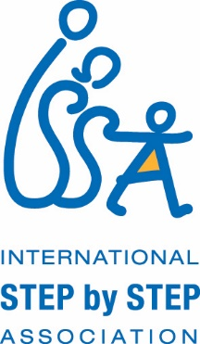

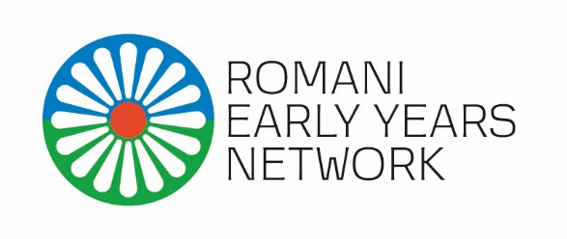

REYN Training
Building a Roma Living Library

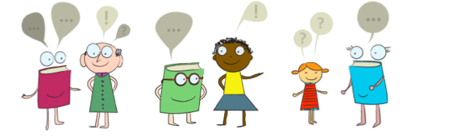

Key messages of the training

Do not judge a book by its cover!

It is easier to split an atom than a prejudice. (A. Einstein)

The Living Library

Living Library is an innovative way to combat stigma and prejudice, and promote understanding between people, intercultural dialogue, human rights, pluralism, and democratic participation.
Its primary aim is to create constructive personal dialogues between people who would normally not have the opportunity to speak to each other and thus challenge common prejudices and stereotypes.

The Living Library attempts to challenge prejudice by facilitating a conversation between two groups of people: the Books and the Readers. In the Living Library, books are not made out of paper; books are people of flesh and blood, with all their experiences, with prejudices that affect them and influence their lives. The Living Books are willing to share their personal experiences of discrimination or social exclusion with the Readers and most importantly, Books give Readers the opportunity to have a dialogue and exchange opinions with them, in the hope that through this process most common stereotypes will be challenged and therefore the attitudes and behaviors of wider society will be changed. Through personal contact with the Living Book, Readers will understand that we are not defined by belonging or not belonging to different groups and that we are all individuals, similar or different, but above all we are human beings with our own stories.

In the Living Library Books are volunteers who have either been subjected to discrimination themselves or represent groups or individuals within society that are at risk of discrimination. After going through a training, the Living Books are ready to be “read” by the public and try to remove the prejudices that Readers sometimes are not even aware that they have.

The Living Library, dedicated to the issues and the world of the Roma and their relationship with non-Roma, is a new approach that ABCittà has studied and introduced with success in Italy. The experience of ABCittà showed that this methodology is very useful for building social cohesion, that it is particularly suitable for large-scale public events, such as festivals and other community gatherings.

Aim of the training:
This training aims to empower a group of REYN members to create Living Libraries with Roma Books in their respective countries.

Goals of the training:
- To understand the ABCittà approach to the Living Library methodology in working with Roma actors;
- To gain knowledge and skills needed for recruiting and training the Living Library Books;
- To gain knowledge and skills needed for organizing Living Library events.

Expected outcomes:
As a result of this training, participants will:
- Get familiar with the history and background of the Living Library methodology;
- Recognize stereotypes, prejudices about Roma people as well as discriminatory practices and formulate a structured list of them;
- Facilitate the connection between prejudice and biographical narrative;
- Accompany the emersion of the biographical narratives;
- Provide support and guidelines for Living Libraries;
- Build, organize and manage a Living Library event.

Training approach
During the training participants will have the opportunity to go through all the phases of the process and will learn trough interactive activities how to create Living Libraries and how to organize Living Library events. They will also find themselves in different roles: they will be human books, readers, librarians and organizers.

Language of the training:
The training will be organized in English.

Duration:
The training will last 3.5 days. Participants will arrive in Skopje, Macedonia, on January 26th and leave on January 29th, 2016.

The training will be conducted by:

ABCittà società cooperativa sociale Onlus
via A.M. Ampère 61/A - 20131 Milano
abcitta@abcitta.org - www.abcitta.org - www.bibliotecavivente.org

NGO ABCittà Cooperative possesses diversified, long-term consolidated experiences in the development and management of local, national and international participatory learning-planning projects in favor of children’s rights and sustainable, livable communities. ABCittà is a not for profit, social cooperative comprised of professionals from the fields of urban planning and policy, architecture, social sciences, pedagogy, education and communication. The cooperative’s primary scope is the design, development and management of complex and integrated participatory processes (learning through planning, planning as learning) aimed at improving and sustaining the quality of children and citizens' lives in changing urban settings. Founded in 1998, from the beginning it has been recognized as a leader in Italy and Europe in projects for the promotion of children’s rights to live in healthy, inclusive, sustainable cities and places and to participate actively in their creation. About their work on Roma Living Library you can see more on http://bibliotecavivente.org/biblioteca-vivente-12-giugno-mondo-rom/ (available only in Italian language, however interesting to watch and get the feel of the process).

